**Shilpa Yadav**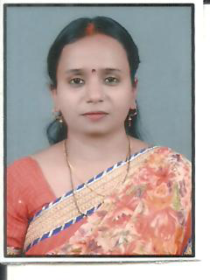

**Assistant professor**

**B.Ed Department**

**Educational Qualification:-**

| **CLASS** | **BOARD/UNIVERSITY** | **YEAR** | **SUBJECTS** | **DIVISION** |
| --- | --- | --- | --- | --- |
| HIGH SCHOOL | U.P.BOARD | 1999 | ALL COMPULSORY SUBJECTS | 1ST |
| INTERMIDIATE | U.P.BOARD | 2001 | ALL COMPULSORY SUBJECTS OF SCIENCE GROUP | 1ST |
| B.Sc. | C.S.J.M.U | 2004 | PHYSICS,CHEMISTRY,MATHS | 2ND |
| M.Sc. | C.S.J.M.U | 2006 | MATHEMATICS | 2ND |
| M.A | C.SJ.M.U | 2014 | EDUCATION | 1ST |

**Professional Qualification:-**

| **CLASS/EXAMINATION** | **UNIVERSITY/INSTITUTION** | **YEAR** | **SUBJECTS** | **DIVISION** |
| --- | --- | --- | --- | --- |
| B.ED. | AGRA UNIVERSITY | 2008 | ALL COMPULSORY SUBJECTS | 2ND |
| M.ED | C.S.J.M.U. | 2010 | ALL COMPULSORY SUBJECTS | 1ST |
| M.Phil. | C.S.J.M.U. | 2012 | EDUCATION | 1ST |
| NET | UGC | 2013 | EDUCATION | -- |
| NET | UGC | 2014 | EDUCATION | ---- |
| NET | UGC | 2015 | EDUCATION | --- |
| NET | UGC | 2017 | EDUCATION | --- |
| NET-JRF | UGC | 2018 | EDUCATION | --- |

* Perusing Ph.D from the Department of Education, C.S.J.M.U Kanpur under the supervision of Dr. Kalpana Agnihotri Ma’am.

**Personal Information:-**

Father’s Name: - Late Mr. Rakesh Kumar Yadav

Date of Birth: - 06/01/1985

Address: -87/194 C Acharya Nagar, Kanpur.

Mobile Number: -8429713521

Email ID: - shilpa6185@gmail.com