**Curriculum vitae**

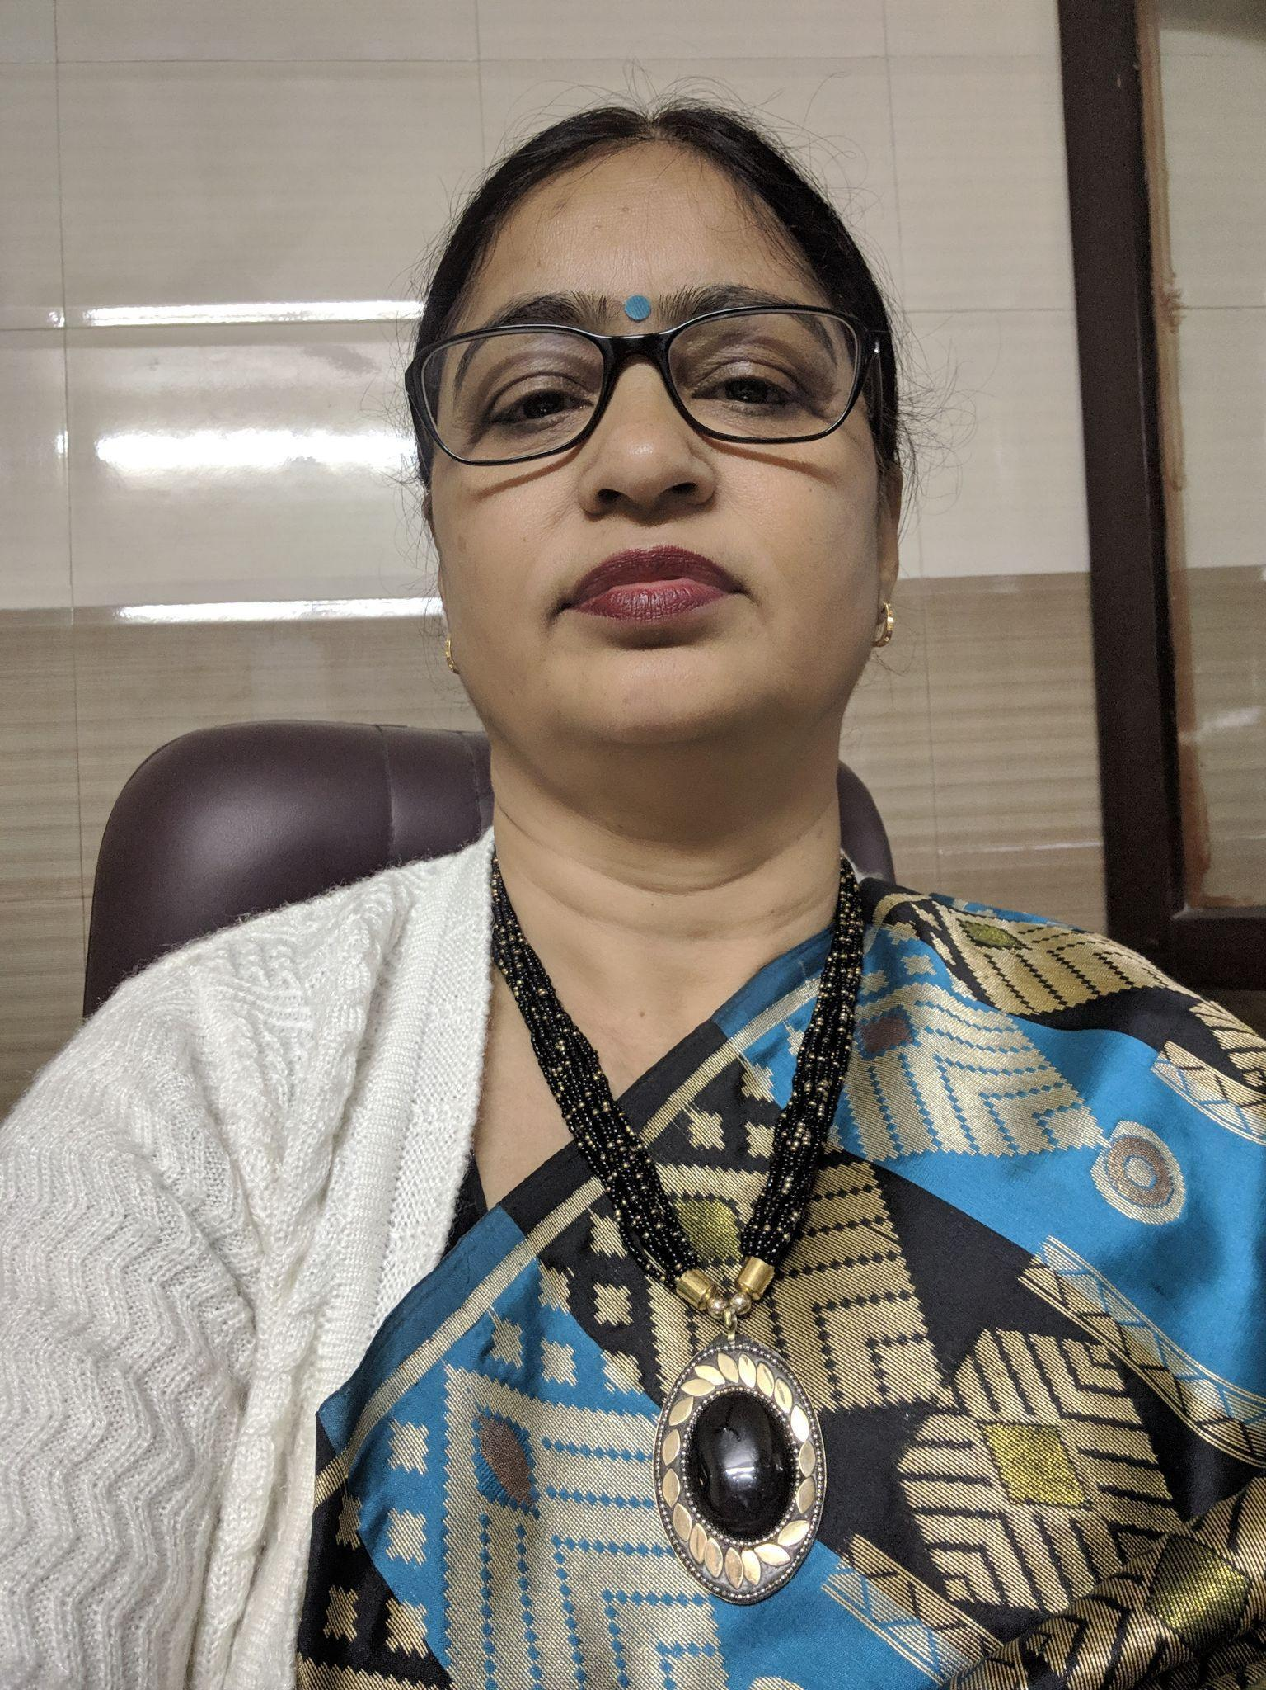

**Dr** **Kshama Tripathi**

**Present Position:**

* Working as Associate Professor - Library in Dayanand Girls P. G. College, Civil Lines, Kanpur Since 7th July 2006
* Subject expert in Chhatrapati Shahu Ji Maharaj University, Kanpur
* Research supervisor in Indira Gandhi National Open University (IGNOU)
* Guest lecturer in Rajarshi Tandon Open University, Allahabad
* Internal Examiner of Chhatrapati Shahu Ji Maharaj University, Kanpur
* External examiner Mahatma Jyotiba Phule Rohilkhand University-Bareilly
* External examiner of Jiwaji University, Gwalior

**Experience :**

* Worked as Librarian in Dayanand Academy of Management Studies, Govind Nagar Kanpur from 25th August 1998 to 6th July 2006
* Worked as Administrative Officer in Dayanand Academy of Management Studies, Govind Nagar, Kanpur for three Years.
* Member of proctorial board of D.G.P.G. College, Kanpur

**Experience in professional training:**

* Provided apprenticeship more than 100 students of Library & Information Science

**Computer Exposure** :

Working Knowledge of

* Computerized Library
* Network System
* Barcode system

**Professional Qualification** :

* Ph.D in Collection Development and Management in Technical and Non Technical Libraries From CMJ University, Shillong
* MLISc from Indira Gandhi Open University, New Delhi.

**Academic Qualifications** :

* Post Graduation in English Literature From Christ Church College, Kanpur.
* Graduation with English Literature, Ancient History & Political Science from Allahabad University, Allahabad

**Book / Book chapters’ publications**:

* **Technological Innovations and Environmental Changes in Modern Libraries** . - New Delhi : Shree Publishers & Distributors, 2021.
* **Cataloguing Practice : Anglo American Cataloguing Rules-2** .- Kanpur : Vikas Prakashan, 2014
* **Access of e-resources among the faculty members and students in the college libraries of CSJM university, Kanpur : a Study** in the Proceedings of the National Conference on Recent TechnologyInnovation towards Best Practices of Libraries in the Knowledge Society(RTIBPLKS-2023) organized by Central Library, Algappa University, Karaikudi-Tamilnadu on 12th &13th Apil 2023.
* **Challenges in managing modern libraries** in the 4th international conference of Asian libraries on “ ICAL-2020 : Managing libraries “ organized by Indian Institute of Management, Lucknow on 26 & 28th Feb., 2020.
* **Intellectual Property Rights** in the 8th international Library and Information Professional Summit on “Empowering Libraries with Emerging Technologies for common sustainable future” organized by Babasaheb Bhimrao Ambedkar University, Lucknow on 22-24th November, 2019.
* **Political Empowerment of women** in the national seminar on “Water and plants: an international environment perspective of 21st century “ organized byIndian Thinker Society, Kanpur on 26th October, 2018.

**Awards:**

* Bharat Excellence Award of 2022 for merit excellent performance and outstanding contribution for the progress of the nation and Worldwide
* Best Teacher Award for the year 2021-2022 of Hall Bol Media Foundation
* Certificate of Honour by Lions Club Kanpur in 2020
* Brand Ambassador of Shri Ramdevi Ramdayal Tripathi Mahila Polytechnic, Kanpur in 2018

**Co-Curricular Activities:**

* Expert lecture was delivered on **"Recent Trends in Library"** in Institute of Research, Development & Training, U.P.
* Resource speakerin Short Term Training Programme on “ Radio Frequency Identification ” held at UP Textile Technology Institute, Kanpur during Sept.18-22, 2017 on “ **RFID”**
* Resource speakerin Short Term Training Programme on “ Knowledge of Organizational Tools” held at UP Textile Technology Institute, Kanpur during 19-23, 2016 on “**Administrative and Management Tools in Library”**

**Conference coordination:**

* International webinar on “Technological Innovations and Environmental Changes in Modern Libraries” organized by Department of Library, Dayanand Girls’ P. G. College, Kanpur on 18th March, 2021.
* “Com-Ference 2007” on “Innovations in Information Technology in Education ” organized by Dayanand Girls P.G. College on 26-27th February, 2007.

**Membership** :

* Membership of International Federation of Library Association ( IFLA)
* Lifetime membership of Indian Library Association (ILA)
* Lifetime membership of Indian Association of Special Libraries and Information Centres (IASLIC)
* Lifetime membership of Uttar Pradesh Library Association (UPLA)

**Paper Publication:**

* **Bharat mei pustakalay adhiniyam aur unki upadeyta : vartman sandharbh mei** in ANUSANDHAN VATIKA(An International Multidisciplinary Quarterly Bilingual

Peer Reviewed Refereed Research Journal) Vol 13 Issue 3 July-September 2023

* **Marketing of Library Products & Services : its Challenges to Professional** in Idealistic Journal of Advanced Research in Progressive Spectrums (IJARPS) Vol. 2, Issue 2, February 2023**B**[**est Reference Sources For Doctoral, Master’s Dissertation And Thesis In Library And Information Science** in](https://journal.ijarms.org/index.php/ijarms/article/view/529) he International Journal of Advanced Research in Multidisciplinary Sciences (IJARMS) Vol. 5, Issue 1, January, 2022
* **Information Retrieval Methods** in dealistic Journal of Advanced Research in Progressive Spectrums (IJARPS) Vol.1, Issue 11, November, 2022
* **Recognising the Role of Libraries in Value Education** in Idealistic Journal of Advanced Research in Progressive Spectrums (IJARPS) Vol.1, Issue 12, December, 2022
* **Pustakalay vigyan and Google apps** in Drishticone vol 13 no. 1 , January- February, 2021
* **Human Resource Development in Academic Libraries in Present Scenario** in the International Journal of Advanced Research in Multidisciplinary Sciences (IJARMS), Vol.3, no.1 ( January**,** 2020)
* **Using of Management Tools for Efficient Working of Modern Libraries** in The International Journal of Advanced Research in Multidisciplinary Sciences (IJARMS), Vol.2, no.1 ( January**,** 2020)
* **Yuvaon ke liye sarkari yojanayen** published in “ Kritika” ( year 12 , no. 23) -January-June 2019
* **Role of Libraries’ Organizations at National and International Level** in The International Journal of Advanced Research in Multidisciplinary Sciences (IJARMS), Vol.1, no.1 (2018) January
* **Karysanskriti aur Vartman Sarkari Yojanayen** in the national seminar on “Bharat ki Kary Sanskriti: badlav ki pahal aur Vikas''organized by Jwala Devi Vidya Mandir P.G. College, Kanpur on 29th &30th March, 2018.
* **Convergence of technologies in Libraries** in the national conference on “ Relevance of Ranganathan philosophy in digital India” organized by department of Library and Information Science, Babasaheb Bhimrao Ambedkar University, Lucknow & Society for promotion of libraries (SPL), Uttar Pradesh on 12th & 13th August, 2017.
* **Internet** In the National Conference “com-Ference-07 on “Innovations in Information Technology in Education” organized by Dayanand Girls P.G. College
* **Eating habits in children**“Eating habits in children” organized by ,department of Psychology, D.G.P.G. College, Kanpur

**Paper Presentation:**

* **Challenges in managing modern libraries** in the 4th international conference of Asian libraries on “ ICAL-2020 : Managing libraries “ organized by Indian Institute of Management, Lucknow on 26 & 28th Feb., 2020.
* **Societal role to protect the environment** in the national seminar on “Paryavaran naitikta evam manaviy mulyon ki upadeyta” sponsored by Higher Education, U P Government and organized by Jwala Devi Vidya Mandir P G College, Kanpur on 15-16 November, 2019.
* **Ethics: in the perspectives of LIS profession** in the “international conference on Rejuvenating Libraries in Modern Society (ICRLMS-2019)” organized by Department of LISc, Babasaheb Bhimrao Ambedkar University, Lucknow & Special Library Association, USA on 18th Feb., 2019
* **Noise pollution: the big health hazard** in the national seminar on “ Environment hazards and its management “ organised by Department of Chemistry, Gramarshi Pt Ramkumar Pandey Gramodaya Ashram P.G. College, Ambedkarnagar, UP on 7th & 8th December, 2018.
* **Five laws in the context of digital era** in the national on “ Relevance of Ranganathan’s philosophy in 21st century “ organised by department of Library and Information Science, Babasaheb Bhimrao Ambedkar University, Lucknow & Society for promotion of libraries (SPL), Uttar Pradesh on 2nd November, 2018.
* **e-governance and service on demand** in the national seminar on “Digital India programme-an initiation to transform nation” organised by Department of Political Science, Government Girls’ P.G. College, Bindaki, Fatehpur on 5-6th October, 2018.
* **Vedon ka hamare Jeevan mei mahatva** in the **Vedon ka hamare Jeevan mei mahatma**  on 11th November, 2017.
* **Terrorism in India** in the national seminar on “Terrorism issues and challenges “ organised by Bhartiya Vicharak Samiti and V.S.S.D. College, Kanpur on 15th May 2017.
* **Aviral Ganga** inthenational seminar on “ Ganga pollution : analysis and remedies “ organised by DAV (P.G.) College, Kanpur on 7th & 8th October, 2016.
* **Metadata Methodology** in the 2nd National Conference of Society for Promotion of Libraries (SPL) on “Libraries Towards Digital Paradigm”(NCLTDP-2014) organized by Department of Library and Information Science in collaboration with Central Library, CSJM, Kanpur on 19-20 April, 2014
* **Sangeet ka hamare jiwan mei mahatva** in the National Seminar on “Uttar Bhartiya Shastriya Sangeet mei Taal evam lay” organized by Department of Music, Dayanans Girls’ P.G. College on 21st January, 2012.
* **Naitik Uttardayitva** in the National seminar on “ Sankalp Swatantrya aur Naitik Uttardayitva” organized by the department of Philosophy, Dayanans Girls’ P.G. College on 17th January, 2012.
* **Consumer Rights**In the National Seminar on “Consumer Protection and Rights” organized by IIPA, Kanpur branch on 12th & 13th February 2011.
* **Paryavaran ka vilop hoti hui prajatiyon me yogdan** in the 4th seminar on “Global Perspective of Biological Researches in the present scenario” sponsored by UGC and organized by Department of Botany, Dayanans Girls’ P.G. College on 7th & 8th December, 2010.
* **Nari astitva : Dr. Bhimrao Ambedkar ke pariprekshya mei**In the National Seminar on “Dr. B. R. Ambedkar’s Views in the Context of Current Global Scenario” sponsored by UGC & organized by Dr. B. R. Ambedkar Study Center, D.G.P.G. College, Kanpur
* **Topic: Nasha samaj me kitana sulbh**In the National Seminar on “ Badalte Parivesh mei Yuvaon mei badti nashe ki Pravritti ka ek shaikshik adhyayan” sponsored by UGC under Major Project Scheme in Dayanans Girls’ P.G. College on 13th November, 2010.
* **RTI : a tool of democracy**“Right to Information Act” organized by Department of Political Science, D.G.P.G. College, Kanpur
* **Pt. Jawwahar Lal Nehru ki videsh niti** National seminar on “Relevance of Pandt Nehru’s thoughts in present scenario” in 55th ILA National Conference on 21st Jan, 2010.at BIMTECH, Greater Noida, UP
* **Innovations in Information Technology in Education**

National conference on "Com-ference-07" organized by Dayanand Girls' P. G. College on 26-27 th February, 2007

**Seminar & workshops attended:**

* “Globalization & its Impact on Economy”organized by Deptt. of Economics, Dayanand Girls College,Civil Lines, Kanpur.
* “Accounting Challenge in 21st Centuary” organized by Deptt.of Commerce, Dayanand Anglo Vadic College, Civil Lines,Kanpur.
* “Drishti 2k” organized by Dayanand Academy of Management Studies, Govind Nagar,Kanpur.
* “Tally” organized by FEMINT
* “Improved Methods in Practice of Teaching” organized by Department of B.Ed. in Dayanans Girls’ P.G. College on 25th & 26th February, 2010
* 55th ILA Conference on “Library and Information Science in the Digital Era” jointly organized by Birla Institute of Management Technology (BIMTECH) in association with Ranganathan Society Welfare & Library Development (RSSWLD) during 21-24th January, 2010.
* National seminar on “Impact of Information Technology in Library & Information Science” organized by I.L.A., New Delhi
* National Conference “com-Ference-07 on Innovations in Information Technology in Education” organized by Dayanand Girls P.G. College on 26-27th February, 2007.

**Personal Information:**

**Email**  : [drkshamat@gmail.com](mailto:drkshamat@gmail.com)

Vidvan I’d : 226584

**Postal Address :** Flat no. 303 Jawahar Nagar, 109/150 Jawahar Nagar

Kanpur-208012

**Date of Birth**  : 13th Nov 1969

**Phone Nos.**  : 9415749733

9125817371

**Marital Position** : Married

**Reference**s :

* Prof. Archana Varma, Principal

Dayanand Girls College,

Civil Lines, Kanpur.

* Dr.Sadhana Singh, Ex- principal

Dayanand Girls College,

Civil Lines, Kanpur.

**Date:29.11.2023 (Dr. Kshama Tripathi)**